# **WTP wireframes**

# Created on January 27 2014

# **Table of Contents**

1.0. App

2.0. Website

# **1.0. App**

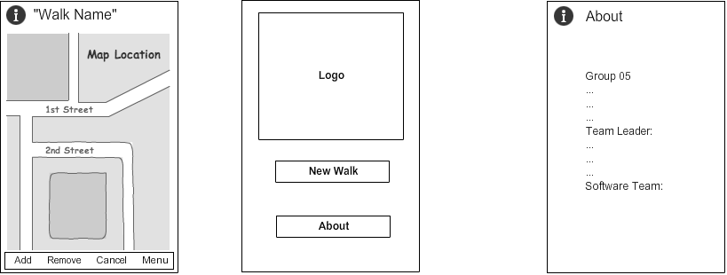

# **2.0. Website**

